THE INVESTMENT ANALYSTS JOURNAL

GTF Brooke and ET Fraser*

Investment Basics: XLII. Options pricing using the Black-Scholes Model
* GTF Brooke is a research assistant and ET Fraser is a lecturer at the School of Management Studies, University of Cape Town, Private Bag, Rondebosch 7700, Republic of South Africa. Email: gbrooke@commerce.uct.ac.za or efraser@commerce.uct.ac.za. The authors would like to thank Herman Steyn and Guy Toms of Prescient Investment Management for input and comments.

1. INTRODUCTION∗*
The Black-Scholes option-pricing model is possibly the most widely taught, and best-known option pricing model in finance today. The model was first presented in the 1973 paper, “The Pricing of Options and Corporate Liabilities”.
At a fundamental level, there are two types of option. A call option gives the holder the right, but not the obligation, to purchase an asset; a put option gives the holder the right, but not the obligation, to sell an asset¹. The price at which the asset will be bought or sold, the exercise price, is set when the option is created/written. There are two further divisions into which options fall. American style options may be exercised at any point up to the expiration date. European style options may only be exercised on the expiration date. A recent addition to these divisions is a Bermudan² option, which may be exercised at any one of various pre-set points during the life of the option.
An option derives value primarily from three sources³. The first is the intrinsic value, the value to an investor who exercises immediately. It is the difference between the share price and the exercise price. The moneyness of an option refers to the intrinsic value. If a call option is ‘in-the-money’, the share price is greater than the exercise price and the investor will benefit from buying the share at the agreed exercise price and selling it at the spot price. Conversely, if a call option is ‘out-of-the-money’ the share price is less than the exercise price, and the investor will not benefit from immediate exercise.⁴
The second source of value is the time value. If an option is out-of-the-money now, there is still a possibility that it will be in-the-money at expiration. The time value of the option is derived from the time remaining to maturity.⁵ In pricing the time value, an investor needs to take account of both the probability of the option maturing in-the-money, as well as the degree to which it will be in-the-money.
The third factor contributing to the value of the option is the volatility of the underlying share. Volatility, in this sense, can be defined as the degree of uncertainty with respect to the future price of the share. The higher the volatility is, the wider the range of potential future prices. This results in a proportionately wide range of possible outcomes for the shareholder. A large decrease in the stock price would result in a large loss (risk) while a large increase in the stock price would result in a large gain (reward). The possible reward of a large gain compensates for the potential risk of a large loss. For the owner of a call option, however, the downside is limited to the cost of the option. Therefore the value of the option increases as the volatility of the underlying share increases. Volatility cannot be observed but can be estimated from the history of the share price. The most common measure of volatility is the standard deviation of the returns on the share.
The value arising from the time to expiration and that arising from volatility are related. The shorter the time to expiration the less the uncertainty with respect to future share prices and therefore the lower the value of the volatility and vice versa.
¹For the purposes of this discussion we will use a share as an example of the type of asset that would be used as the underlying asset.
²The name Bermudan is derived as a result of the option’s exercise possibilities being somewhat more flexible than the rigidity of the European option while less so than the ultra-flexible American option.
³Figure 1 illustrates how the Black-Scholes model captures these three sources of value.
⁴If a put option is ‘in-the-money’, the share price is less than the exercise price and the investor will benefit from buying the share at the spot price and selling at the exercise price. Conversely, if a put option is ‘out-of-the-money’, the share price is greater than the exercise price and the investor not benefit from immediate exercise.
⁵The closer the option is to maturity the less the time value.

2. THE BLACK-SCHOLES MODEL
The original derivation of the Black-Scholes Model was based on a number of assumptions. While many of them may appear restrictive, subsequent work has allowed for some of them to be relaxed. These relaxations are discussed later.
In developing the model, the authors considered the case of a call option on a single share.
The first assumption relates to the nature of the market. It is assumed that a no-arbitrage condition holds, and that a perfectly hedged portfolio will earn the risk-free rate of return. A no-arbitrage condition actually arises from a more fundamental assumption that traders are willing to take advantage of any arbitrage⁶ opportunities that they identify. The result of this is that any such opportunities will be traded away very quickly and thereafter none will exist. The implication is that it is not possible to earn more than the risk-free rate without bearing risk.

The other assumptions are:
i) The short-term risk free rate is known and constant during the life of the option.
The return on a short-term interest-bearing instrument is typically used as a proxy for the risk-free rate. Since the return on a share is quoted as a yield, the return used as the risk-free proxy should be quoted in the same way. This may require a conversion from a discount rate should the instrument chosen be a discount instrument. Furthermore, the assumption of constancy is questionable since short-term rates do fluctuate. The longer the term of the option the greater the expected fluctuation in the risk-free rate, or its proxy, is. However, when valuing short-term options the fluctuation may be small or non-existent and therefore the assumption reasonable. In the instance of a non-constant risk-free rate, a government interest-bearing instrument maturing at the expiration of the option could be used as a proxy for the risk-free rate. When valuing longer-term options it may be necessary to consider using an alternative valuation method such as a binomial lattice, which is more able to accommodate such fluctuations. This alternative is the subject of Investment Basics xxxviii (Page, 1998).

ii) The price of the share follows a random walk. Therefore a lognormal distribution describes the possible distribution of future share prices. Additionally, the variance of the share return is assumed constant for the life of the option.
The random walk assumption has been the cause of much academic debate over the last forty years. However, what is clear is that the variance of the share return may not be constant, particularly over longer periods. A rolling variance can be used. As above, an alternative valuation method can be used for longer-term options.

iii) No dividends or distributions are made during the life of the option.
The violations of this assumption and possible solutions are discussed below.

iv) The option being priced is European style.
Merton (1973) demonstrated that, provided that all other assumptions hold, an option is always worth more ‘alive than dead’ i.e. trading the option in the market will be preferable to early exercise. Thus, an American and European call option will always have the same value, and the model can then be used to price either.

v) The market is frictionless i.e. there are no transaction costs involved in buying or selling the option or the underlying share.
In practice there are various transactions costs. The transactions costs for options trading in South Africa are shown in Table One. In addition marketable securities tax (MST) must be paid, as well as custodian transactions cost of R70.00 per transaction on settlement and the bank charges resulting from the payment of funds. However, as can be seen, in the options market these costs are in fact relatively small and can therefore reasonably be ignored.

vi) Money can be borrowed and lent at the risk-free rate of interest.
This assumption is violated in the real world in two ways. It is seldom true that market participants, other than very large institutions, are able to borrow at the risk-free rate, as the lenders require a risk premium. In addition, the margin between the lending and the borrowing rate is a major source of profit to financial intermediaries and thus the rate at which money is lent by an intermediary is greater than the rate at which deposits are taken.

Table 1: Transactions Cost for Trading Options in South Africa

 | Transactions Cost
Options on Equities (Warrants) | 0,35% of the option value
Options on Bonds | R60 per R1 million nominal
Options on Futures | R20 per contract

vii) Short selling is possible, and there are no penalties associated with it.
In South Africa short selling is permitted but only within strict limits, which for some market participants may be restrictive. In addition, it is costly.
The model was then developed as followsError: Reference source not found:

$$C_{0}=S_{0}N\left(d_{1}\right)−{\text{Xe}}^{−r_{f}T}N\left(d_{2}\right)$$
where: $d_{1}=\frac{\text{ln}\left(\frac{S_{0}}{X}\right)+r_{f}T+12σ^{2}T}{σ\sqrt{T}}$

$d_{2}=d_{1}−σ\sqrt{T}$

$C_{0}$ = current call price;
$S_{0}$ = current share price;
$N\left(d\right)$ = the probability that a random draw from the standard normal distribution will yield a value less than d;
$X$ = the exercise price;
$e$ = the base of the natural log function;
$r_{f}$ = the risk-free rate;
$T$ = the number of years to maturity; and
$σ$ = the standard deviation of the return on the share.

The intuition behind the model is as follows and is illustrated in Figure 1. S₀-X is the difference between the spot share price and the exercise price and represents the intrinsic value of the option today. e^{-rt} is the continuously compounded present value factor. Xe^{-rt} is the present value of the exercise price.
This is the present value of the option holder’s contingent liability at expiration and is the amount that, if invested at the risk-free rate, would grow sufficiently to pay the exercise price at expiration. The two N(d) terms together capture volatility and loosely represent the probability, accounting for risk, of the option expiring in-the-money i.e. with S₀ > X.
The data required is as follows:

S₀ = last traded share price on the date of valuation.
X = exercise price as defined by the option contract.
r_{f} = yield return on the risk-free proxy, for example a 30 day NCD, expressed as an annual percentage.
T = time to expiry from date of valuation expressed as a fraction of a year. Expiry date is per the option contract.
σ = the standard deviation of the returns on the share, excluding dividends, expressed as a percentage. The calculation of standard deviation is controversial and the subject of ongoing debate. Hull (1997) suggests the use of daily returns for the last 90 to 180 days.
The N(d) terms are determined by the position of d₁ and d₂ on the normal distribution curve and represent the area under the curve up to points d₁ and d₂. Practically, the data described above is used to calculate d₁ and d₂. Most simply, N(d₁) and N(d₂) can then be read off a cumulative normal distribution table.
It is worth noting that in practice, volatility of the share price as measured by σ is often implied from the actual market price of the option. Since all the other variables are observable, the Black-Scholes option-pricing formula is set equal to the market price for the option and σ is solved for. This results in the volatility implied by the market and is known as ‘implied volatility’. While this is useful for monitoring the market sentiment and for using one option price to price another, it is not necessarily useful in determining a fair price for an option.

⁶ Hull (1997:12) defines arbitrage in the following way “Arbitrage involves locking in a riskless profit by entering simultaneously into transactions in two or more markets.”

3. RELAXING THE NO-DIVIDEND ASSUMPTION
If the no-dividend assumption is violated, in some circumstances it may pay to exercise early, specifically in the period immediately prior to the share going ex-dividend. In these instances, an American option is worth more than a European option, and can therefore not be priced using the Black-Scholes model.
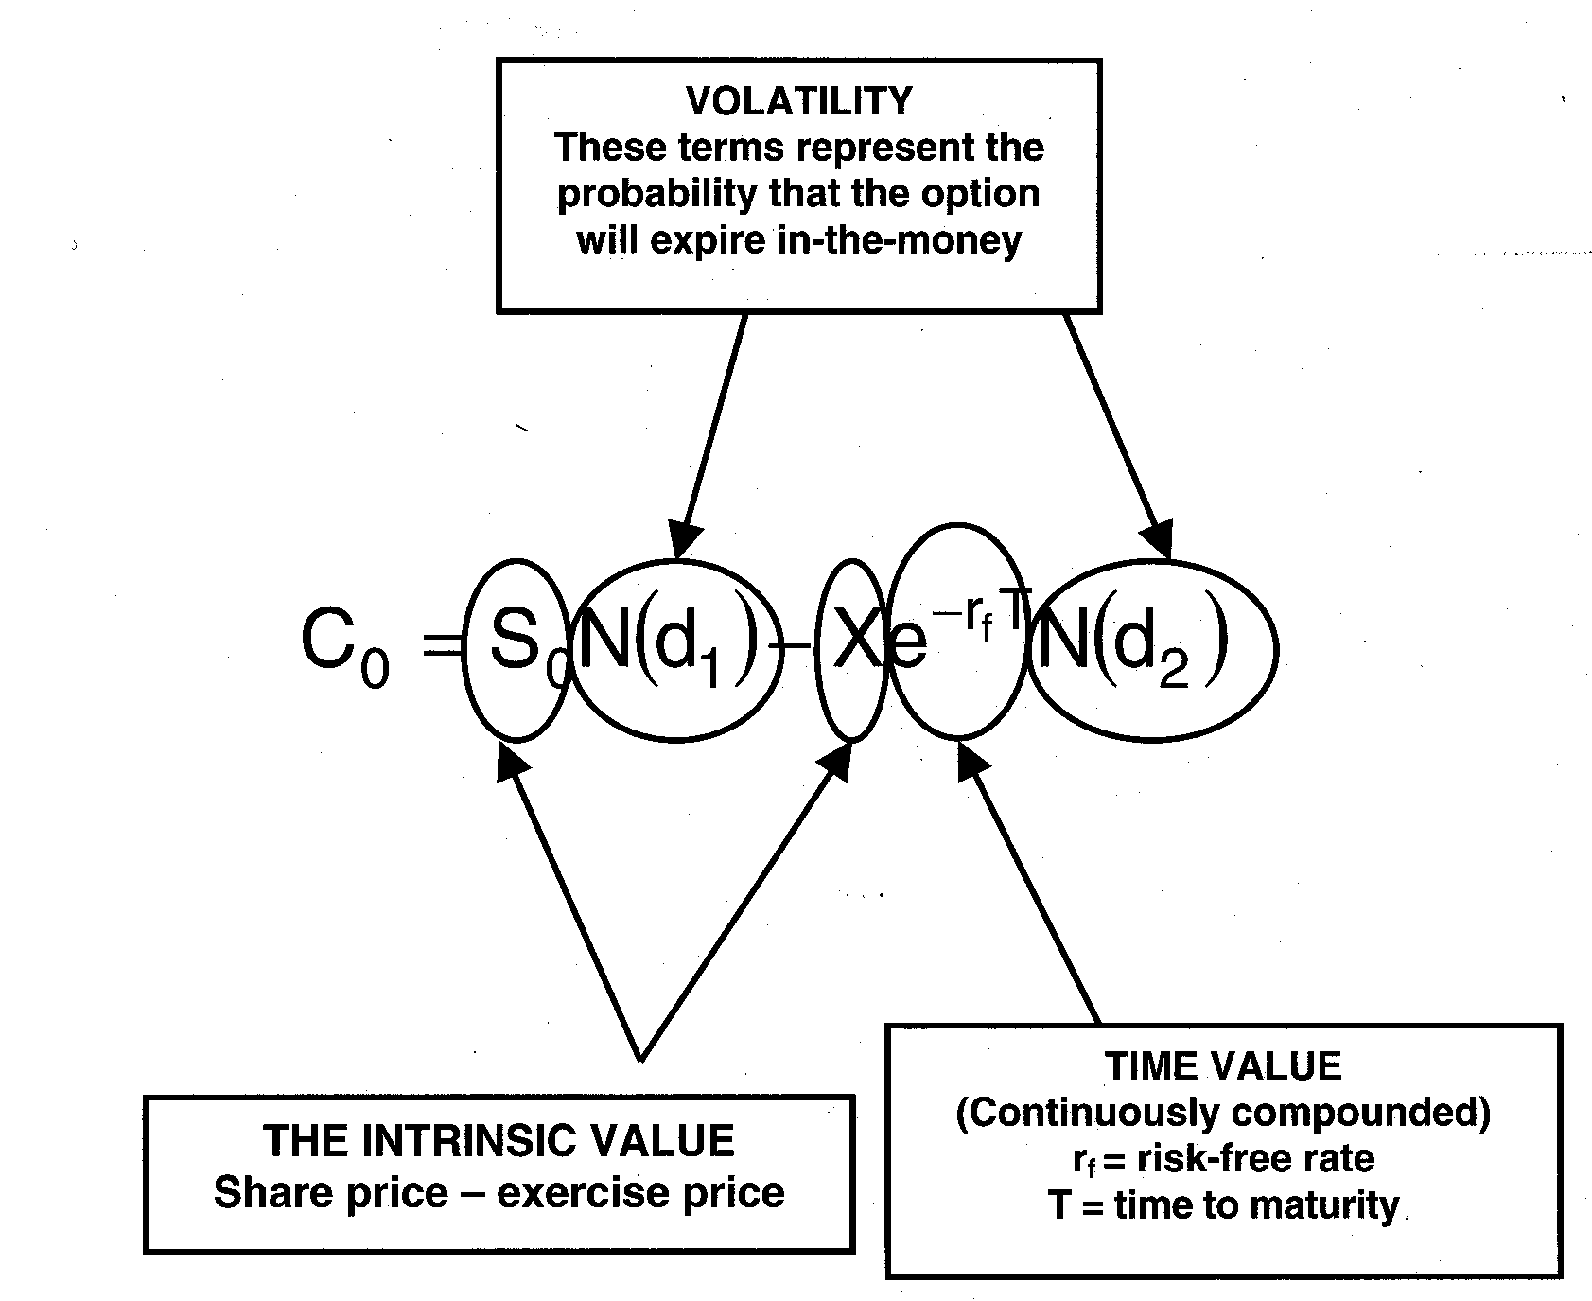$C_{0}=S_{0}N\left(d_{1}\right)−{\text{Xe}}^{−r_{f}T}N\left(d_{2}\right)$

VOLATILITY
These terms represent the probability that the option will expire in-the-money
TIME VALUE
(Continuously compounded)
r_{f} = risk-free rate

T = time to maturity
THE INTRINSIC VALUE
Share price – exercise price
Figure 1

Two methods have been proposed for dealing with dividends. The first is to reduce the share price by the amount of the dividend. This effectively removes the impact of the dividend before the Black-Scholes model is used. The second method, proposed by Merton (1973), was to derive the model allowing for a continuous dividend yield. The model as restated by Merton is as follows:

$$C_{0}=S_{0}e^{−\text{dT}}N\left(d_{1}\right)−{\text{Xe}}^{−r_{f}T}N\left(d_{2}\right)$$

where symbols are as previously defined except for:

$d_{1}=\frac{\text{ln}\left(\frac{S_{0}}{X}\right)+r_{f}T−\text{dT}+12σ^{2}T}{σ\sqrt{T}}$
d = dividend yield

The question of dividends does still remain a problem. In the market, exercise prices are often reduced by the amount of the dividend. In pushing this idea to the limit, Black and Scholes consider the case of a firm liquidating all assets, and then paying a dividend equal to the asset value of the firm. A simple reduction of the exercise price will not fully reflect the fact that the option has no value.
Black and Scholes also draw attention to the problems in using the model to price options other than short-lived options. They consider the case of warrants. By the American definition, a warrant is a long dated option issued by the firm whose share forms the underlying security. New shares are issued upon exercise. In South Africa and a number of other countries the term warrant simply refers to a long dated option. As applies to South African warrants, the problems centre on the assumption of constant volatility of the share returns, as well as a constant risk-free rate. While it may be reasonable to assume that these remain constant over a short period, such as a number of months, it is not necessarily a reasonable assumption for long dated options, such as warrants, whose lives are measured in years.

4. EMPIRICAL EVIDENCE
In empirical tests of the model, Black and Scholes found that while option writers tend to receive a fair price, purchasers tend to pay more than fair value. The differences are contained in the trading costs, which appear to be carried by the purchaser. In addition they also find that the difference between the model value and the price paid by investors is greater for options on low volatility stock than for options on high volatility stock.
Since then the empirical evidence has been mixed and in some instances contradictory. Macbeth and Merville (1979) found that the model priced in-the-money options lower than the market, and out-of-the-money options higher than the market. Merton (1976) found that the model prices deep in-the-money and deep out-of-the-money options above the market. Black (1975) found that the model priced in-the-money options above the market and out-of-the-money options below the market
In pricing warrants listed on the JSE, Brooke, Mitchell, Pawley, Quayle (1999) found that the model priced out-of-the-money warrants higher than the market. The data for in-the-money warrants was limited, but the model produced values closer to market value.

REFERENCES
Black F. 1975. Fact and fantasy in the use of options. Financial Analysts Journal, 31 (July-August):36-41, 61-72.
Black F and Scholes M. 1973. The pricing of options and corporate liabilities. Journal of Political Economy, 81:637-659.
Bodie Z, Kane A and Marcus A. 1996. Investments. Boston. Irwin McGraw-Hill. 3rd Edition.
Brooke GTF, Mitchell J, Pawley SP and Quayle B. 1999. Pricing warrants on the J.S.E using the Black Scholes Option Pricing Model. Unpublished UCT Honours research report.
Hull JC. 1997. Options, futures and other derivatives. USA. Prentice Hall. 3rd Edition.
Macbeth JD and Merville LJ. 1979. An empirical examination of the Black-Scholes Call Option Pricing Model. Journal of Finance, 34(5):1173-1186.
Merton RC. 1973. Theory of rational option pricing. Bell Journal of Economics and Management Science, Spring:141-183.
Merton RC. 1976. The impact on option pricing of specification error in the underlying stock price returns. Journal of Finance, 31 May: 333-350.
Page MJ. 1998. Investment Basics:XXXVIII. Options pricing using a binomial lattice. Investments Analysts Journal, 48:67-69.


* GTF Brooke is a research assistant and ET Fraser is a lecturer at the School of Management Studies, University of Cape Town, Private Bag, Rondebosch 7700, Republic of South Africa. Email: gbrooke@commerce.uct.ac.za or efraser@commerce.uct.ac.za. The authors would like to thank Herman Steyn and Guy Toms of Prescient Investment Management for input and comments.

